 | SIGNAGE REQUEST FORM
 | Form CT-03 | 11777 San Vicente

To order signage for your suite in the Building, please complete this form, have an authorized person sign it and return it to the Office of the Building.

Tenant Name: |  | Contact Phone #:
Suite No.: |  | Date:

Please proofread all copy carefully, as we cannot be responsible for errors. If you are not sure, please confirm with us the maximum characters, including punctuation and spaces.

DOOR PLAQUE (max 6 lines of text with approximately 30 characters per line, including punctuation)
Sample | Please print or type exact copy as it should appear: | Suite No.:
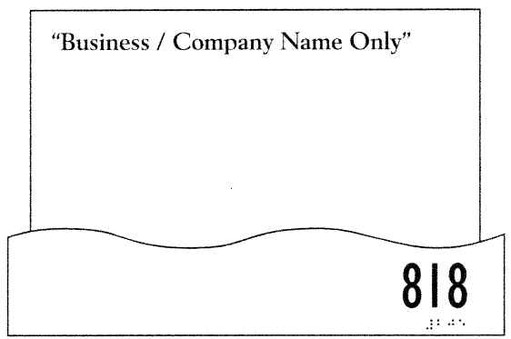

FIXED BOARD LOBBY DIRECTORY
Please print or type directory strip tenant name: | Suite No.:

Your account will be billed in accordance with our standard practices for the requested services, including an administrative fee as applicable on third party charges. If you have any questions about how your charges will be calculated, please discuss them with us before submitting this form.

Tenant Authorized Person: | Signature:
Tenant Authorized Person: | Type/print name & title:

